Trip Stats Function – CGEA 1.3

Functional Description

The Trip Stats function provides two sets of trip statistics with each set having 6 sub-functions (Trip Distance Traveled, Trip EV Distance Traveled (eTrip), Trip Average Fuel Economy (AFE), Trip equivalent Average Fuel Economy (eAFE), Trip Fuel Used and Trip Timer). Each set of Trip Stats’ sub-functions can be reset together by the user through the Message Center. Also, each set of Trip Stats’ sub-functions can be paused and restarted together by the user through the Message Center.

The Trip Distance Traveled sub-function uses the Odometer input value to determine the distance traveled since last Trip Stats’ reset and while Trip Stats is running.

The Trip EV Distance Traveled sub-function uses the Odometer input value to determine the distance traveled while in EV since last Trip Stats’ reset and while Trip Stats is running.

Trip Average Fuel Economy sub-function uses its associated Trip Distance Traveled and Trip Fuel Used sub-functions to determine the average fuel economy since last Trip Stats’ reset and while Trip Stats is running.

Trip equivalent Average Fuel Economy sub-function uses its associated Trip Distance Traveled, Fuel Used and Trip equivalent Fuel Used sub-functions to determine the equivalent average fuel economy since last Trip Stats’ reset and while Trip Stats is running. The equivalent Fuel Used input (ElFuelFlw_Vl_Dsply) is a forward and reverse rolling count variable.

Trip Fuel Used sub-function uses a signal from the PCM, that indicates the amount of fuel that is sent to the engine, to determine fuel used since last Trip Stats’ reset and while Trip Stats is running. On European vehicles, there is also an optional Fuel Operated Heater (FOH), which has a separate signal for the incremental fuel used.

Trip Timer sub-function uses the cluster internal clock to determine the elapsed time that has accumulated since last Trip Stats’ reset and while Trip Stats is running.

Interfaces

Interface Context Diagram (I/O Block Diagram)
Figure 1.1 Trip Stats Function Context Diagram
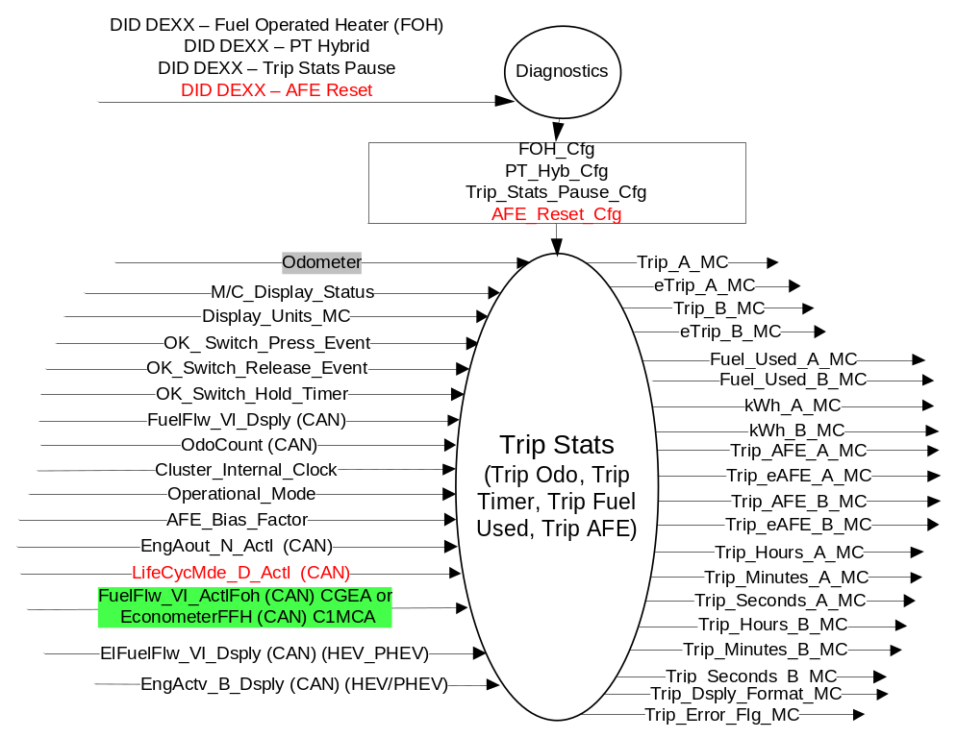

Inputs
- INTERNAL:
  - Operational_Mode
  - M/C_Display_Status
  - Display_Units_MC
  - Cluster_Internal_Clock
  - OK Switch Press Event
  - OK Switch Release Event
  - OK Switch Hold Timer
  - AFE_Bias_Factor (From Fuel Economy STSS)
  - Odometer (From Odometer STSS)

- MUX messages on the CAN Bus

- FuelFlw_Vl_Dsply (CAN) Signal
Signal Name | Size (bits) | Detail | Units | Res. | Offset | State Encoded | Min | Max
FuelFlw_Vl_Dsply | 10 |  | microL | 25 | 0 |  | 0 (0x00) | 25575 (0x3FF)

- At every transition to RUN/START FuelFlw_Vl_Dsply signal value is reset to zero.
- At every transition to RUN/START, the expected value of FuelFlw_Vl_Dsply and Previous_FF are reset to the value in the first received CAN FuelFlw_Vl_Dsply signal.
- For clusters that do not have FNOS configured to generate an event when a periodic message is received, the following (less desirable) alternate implementation of the above requirement is allowed:
  - At every transition to RUN/START, the expected value of FuelFlw_Vl_Dsply is reset to the value in the CAN Rx buffer.

- ElFuelFlw_Vl_Dsply (CAN) Signal (HEV/PHEV Only)
Signal Name | Size (bits) | Detail | Units | Res. | Offset | State Encoded | Min | Max
ElFuelFlw_Vl_Dsply | 10 |  | Micro_Liter_ElEquiv | 25 | 0 |  | 0 (0x00) | 25575 (0x3FF)

- At every transition to RUN/START, the expected value of ElFuelFlw_Vl_Dsply and Previous_ElFF are reset to the value in the first received CAN ElFuelFlw_Vl_Dsply signal.
- For clusters that do not have FNOS configured to generate an event when a periodic message is received, the following (less desirable) alternate implementation of the above requirement is allowed:
  - At every transition to RUN/START, the expected value of ElFuelFlw_Vl_Dsply is reset to the value in the CAN Rx buffer.
- ElFuelFlw_Vl_Dsply is a forward and reverse rolling count variable on PHEV

- OdoCount (CAN) Signal
Signal Name | Size (bits) | Detail | Units | Res. | Offset | State Encoded | Min | Max
OdoCount | 8 |  | meters | .2 | 0 |  | 0 (0x00) | 50.8 (0xFE)
 |  | Invalid |  |  |  | 0xFF

- OdoCount Signal value is 256 steps, transition from 254 to 0 is two steps for the cluster. A 255 (0xFF) is used only in error handling of invalid data from the PCM.
- At every transition to RUN/START OdoCount Signal value is reset to zero.
- At every transition to RUN/START, the expected value of OdoCount and Previous_ODO are reset to the value in the first received CAN OdoCount signal.
- For clusters that do not have FNOS configured to generate an event when a periodic message is received, the following (less desirable) alternate implementation of the above requirement is allowed:
  - At every transition to RUN/START, the expected value of OdoCount is reset to the value in the CAN Rx buffer.

- FuelFlw_Vl_ActlFoh (CAN) Signal
Signal Name | Size (bits) | Detail | Units | Res. | Offset | State Encoded | Min | Max
FuelFlw_Vl_ActlFoh | 16 |  | microL | 25 | 0 |  | 0 (0x00) | 1638375 (0xFFFF)
- This signal initializes differently than FuelFlw_Vl_Dsply. After a battery connect, the expected value of FuelFlw_Vl_ActlFoh and FE_Previous_FF_FOH are reset to the value in the first received CAN FuelFlw_Vl_ActlFoh signal. The FOH module will initialize to 0 at its battery connect and then it retains, uses and transmits the rolling count value, where a 0 is a valid value.

- EconometerFFH (CAN) Signal (C1MCA architecture only – C34x PHEV/FHEV)
Signal Name | Size (bits) | Detail | Units | Res. | Offset | State Encoded | Min | Max
EconometerFFH | 8 |  | microL | 2000 | 0 |  | 0 (0x00) | 510000 (0xFF)
- This signal initializes differently than FuelFlw_Vl_Dsply. After a battery connect, the expected value of FuelFlw_Vl_ActlFoh and FE_Previous_FF_FOH are reset to the value in the first received CAN FuelFlw_Vl_ActlFoh signal. The FOH module will initialize to 0 at its battery connect and then it retains, uses and transmits the rolling count value, where a 0 is a valid value.
- This Table 1.4 replaces Table 1.3 above on C1MCA vehicles (i.e. C34x *EV)

- EngAout_N_Actl (CAN) Signal
Signal Name | Size (bits) | Detail | Units | Res. | Offset | State Encoded | Min | Max
EngAout_N_Actl | 13 |  | RPM | 2 | 0 |  | 0 (0x0) | 16382 (0x1FFF)

- EngActv_B_Dsply (CAN) Signal (HEV/PHEV Only)
Signal Name | Size (bits) | Detail | Units | Res. | Offset | State Encoded | Min | Max
EngActv_B_Dsply | 1 |  | SED | 1 | 0 |  | 0 (0x0) | 1 (0x1)
 |  | Off |  |  |  | 0x0
 |  | On |  |  |  | 0x1

- CAN Signals
Signal Name | Size (bits) | Detail | Units | Res. | Offset | State Encoded | Min | Max
LifeCycMde_D_Actl | 4 |  | SED | 1 | 0 |  | 0 (0x0) | 3 (0x3)
LifeCycMde_D_Actl |  | Normal |  |  |  | 0x0
LifeCycMde_D_Actl |  | Factory |  |  |  | 0x1
LifeCycMde_D_Actl |  | NotUsed |  |  |  | 0x2
LifeCycMde_D_Actl |  | Transport |  |  |  | 0x3

Outputs
- Trip_A_MC
- Trip_B_MC
- eTrip_A_MC
- eTrip_B_MC
- Fuel_Used_A_MC
- Fuel_Used_B_MC
- kWh_A_MC
- kWh_B_MC
- Trip_AFE_A_MC
- Trip_AFE_B_MC
- Trip_eAFE_A_MC
- Trip_eAFE_B_MC
- Trip_Hours_A_MC
- Trip_Minutes_A_MC
- Trip_Seconds_A_MC
- Trip_Hours_B_MC
- Trip_Minutes_B_MC
- Trip_Seconds_B_MC
- Trip_A_Status_MC
- Trip_B_Status_MC
- Trip_Error_Flag_MC
- Trip_Dsply_Format_MC

Function/Performance

Operational Modes

Mode | Differentiating Vehicle Conditions
Sleep Mode | Trip Stats Function Off
Limited Mode | Trip Stats Function Off (CAN traffic active when bus awake)
Normal Mode | Trip Stats Function Functioning
Crank Mode | Trip Stats Function Functioning

Voltage Levels

Refer to Cluster Features table located in Operational Modes and Voltage Range Strategies Section in this SPSS.

Human-Machine Interface

Visual

Indicator Graphics / Display Format
There are two methods to display the Trip Stats. SETUP is used to determine which of the two are wanted by the customer. Trip A and Trip B can be set individually.

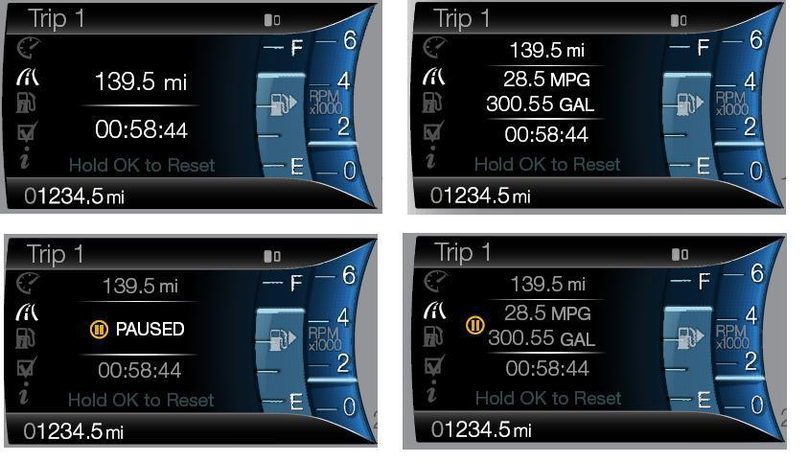
NOTE: Fuel Used should show 2 decimal places. May not fit in all levels of cluster, refer to HMI.

The three methods to display Trip Stats for a PHEV are:

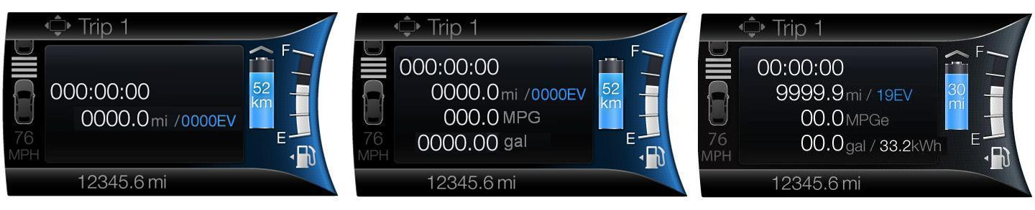

Above are example graphics. eAFE is displayed instead of AFE if Fuel Economy setting is equivalent FE.
Actual graphics are to be provided by Ford HMI or Studio for each program.

For High End Display (SHMI), reference HMI Specifications:
Text: Program Translation Table.xls
Structure: Program Menu Structure.xls
Control Logic: Program HMIDialog_Diagram.pdf
Menu Structure: For High End Display (SHMI), refer to “<Program> Cluster Menu Structure.xls”.

Main Menu | Menu Level 2 | Menu level 3 | Menu level 4
Settings | Display | Trip Display | ◉ Standard
Settings | Display | Trip Display | ○ Enhanced
Settings | Display | Fuel Economy | ◉ Standard
 |  |  | ○ Equivalent

Indicator Color Coordinates

As per Ford Studio Drawing

Indicator Characteristics

As per Ford Studio Drawing

Distance – XXXZ.Z Units (if X is a leading zero, it is omitted)

AFE -- XZ.Z Units when displaying in mpg, L/100km or km/L . Unit value should be clipped to a maximum display of 99.9 Units. In case of PHEV or similar vehicle variants, if appropriate, there can be an option of displaying maximum units as XXZ.Z. Unit value should be clipped to a maximum display of 999.9 mpg or 399.9 km/L. If user tries to change display units at 399.9 Km/L (which is an ideal case), it would still be less than 999.9 mpg. In all cases, if X is a leading zero, it is not displayed. XXZ.Z Units (if X is a leading zero, it is omitted)

eAFE -- XZ.Z Units when displaying in mpg, L/100km or km/L . Unit value should be clipped to a maximum display of 99.9 Units. In case of PHEV or similar vehicle variants, if appropriate, there can be an option of displaying maximum units as XXZ.Z. Unit value should be clipped to a maximum display of 999.9 mpg or 399.9 km/L. If user tries to change display units at 399.9 Km/L (which is an ideal case), it would still be less than 999.9 mpg. In all cases, if X is a leading zero, it is not displayed. XXZ.Z Units (if X is a leading zero, it is omitted)

Fuel Used -- XXXZ.ZZ Units (if X is a leading zero, it is omitted)
kWh Used – XXZ.Z Units OR (XZ.Z when < 100 and ZZZ) (if X is a leading zero, it is omitted)

Time -- XZZ:ZZ:ZZ (if X is a leading zero, it is omitted)

Audio

None

Switch Control Logic

Consumer access to the Trip Stats Function’s display configuration, resetting, pausing and restarting shall be as specified in the Menu Structure Section (STSS).

System Accuracy

- Reference SDS IS-0344, the display update rate for the numeric displayed values shall be no greater than once per second.
- Reference SDS IS-0300 for Timer Accuracy
- Reference SDS IS-0307 for Trip Odometer Accuracy
- Reference SDS IS-0348 for Fuel Used Accuracy
- Reference SDS IS-0358 for AFE Accuracy
- Within a 100msec of receiving a message/input that results in a change of state the cluster will update the display to the proper status.
- Average Fuel Economy algorithm shall introduce less than 0.1% error to displayed value.
- Shall use kilometer to miles conversion constant of 1/1.609344
- Shall use liters to U.S. gallons conversion constant of 1/3.785412
- Shall use U.S. gallons to U.K. gallons conversion constant of 0.8326725
- Algorithm shall introduce less than 0.1% error to displayed value
- Values for Trip, Fuel Used and Timer shall be retained through a Battery Disconnect during key OFF/ACC.

Operation: Performance and Functional

Subsystem Algorithm Flowchart / State Diagram
Figure 1.2 CAN Routine for CGEA
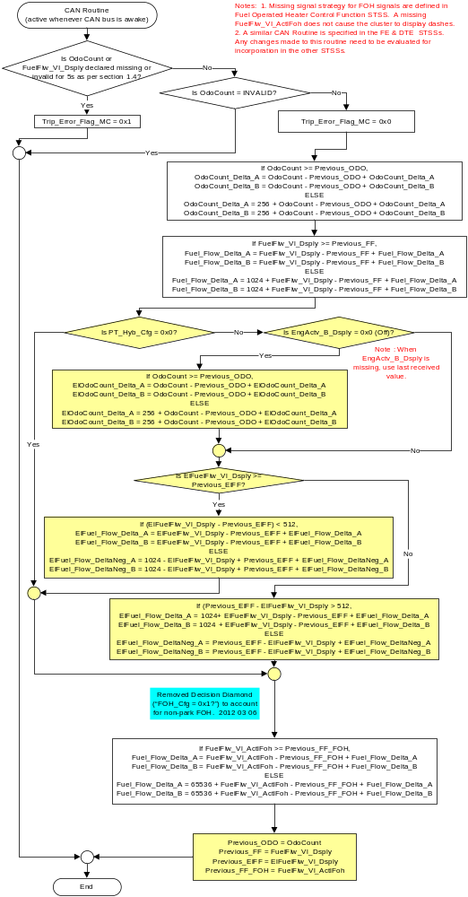
Figure 1.2a CAN Routine for C1MCA (THIS REPLACES FIGURE ABOVE FOR C1MCA VEHICLES – SPECIFICALLY C34x PHEV/FHEV
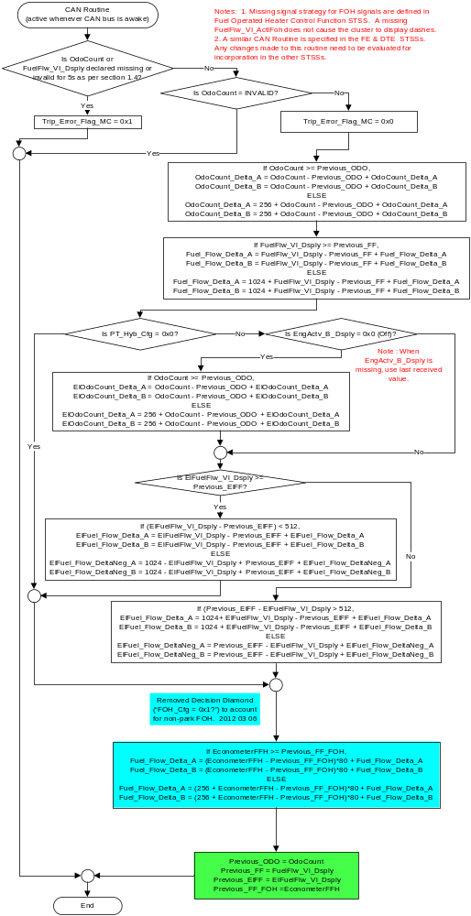
Figure 1.3 Subsystem Flowchart
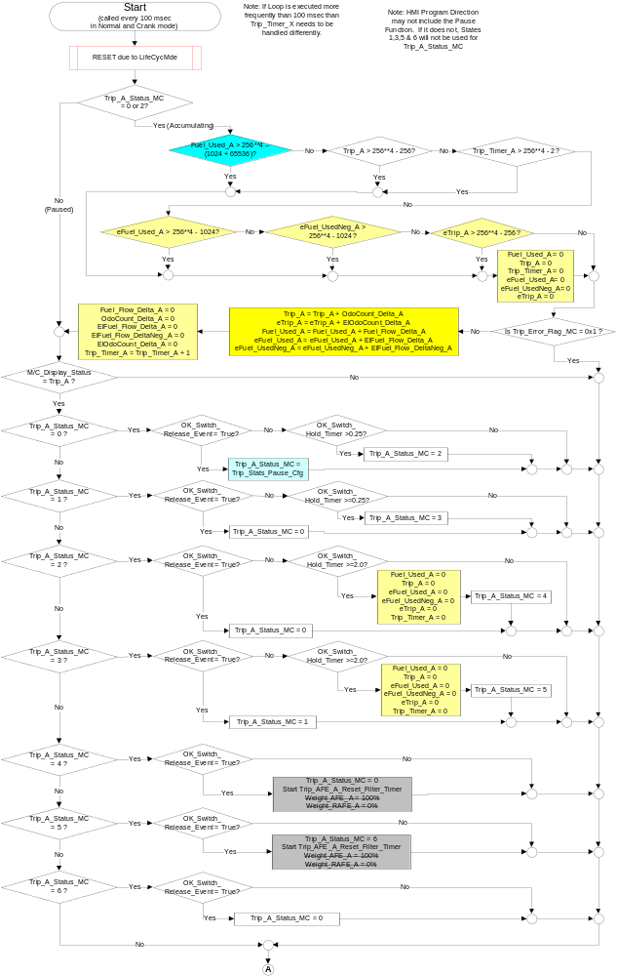
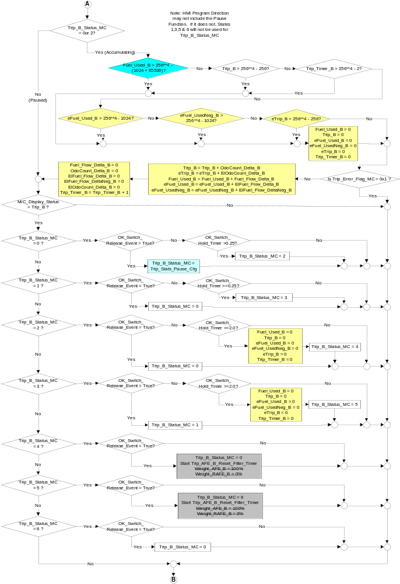
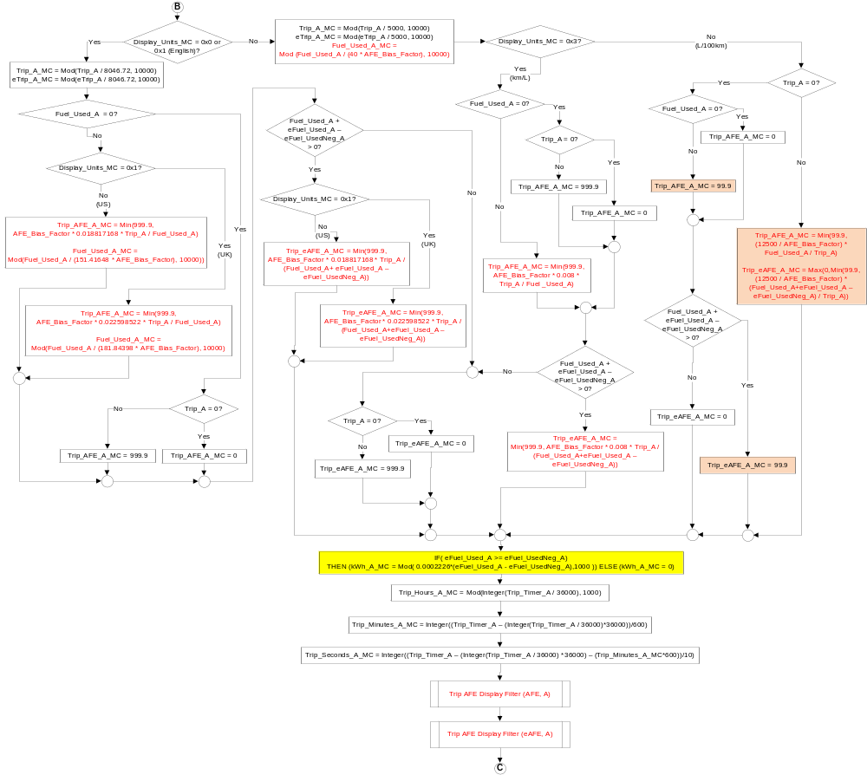
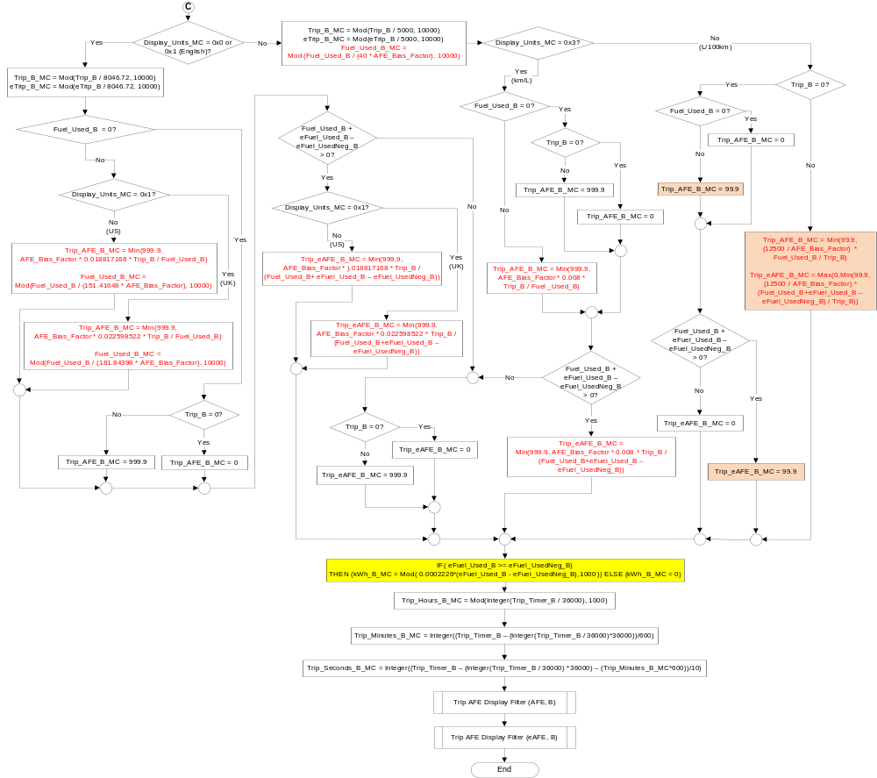
Figure 1.4 Trip Routine Flowchart – Trip AFE Display Filter
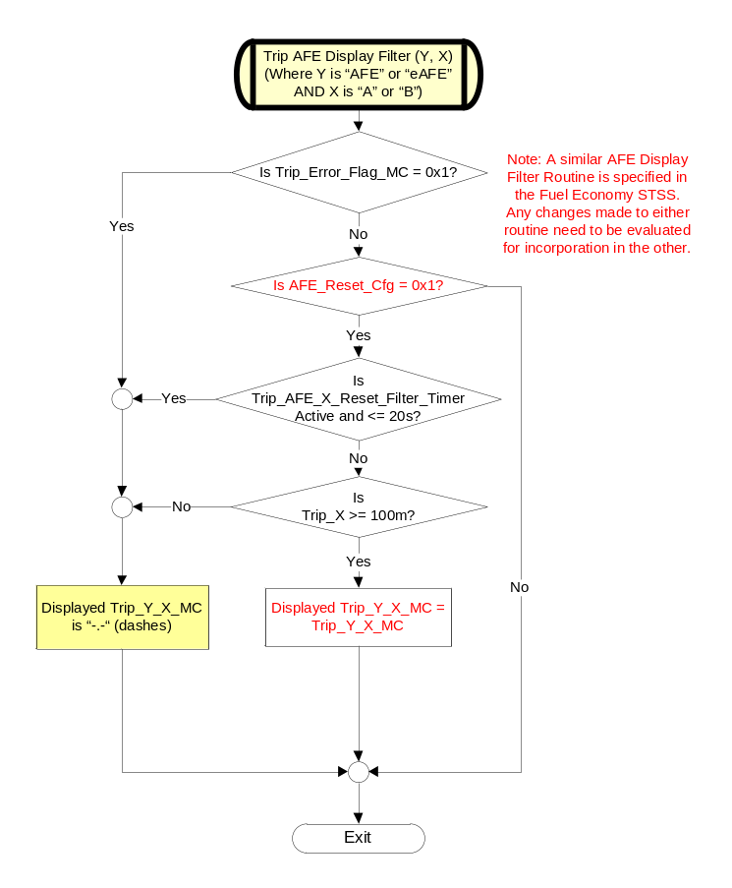
Figure 1.5 Subsystem Flowchart – Limited Mode

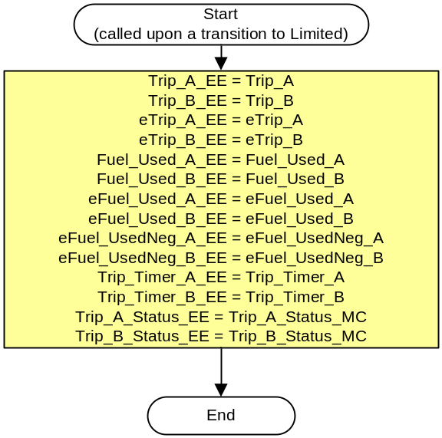

Figure 1.6 Trip Display Control Function Flowchart
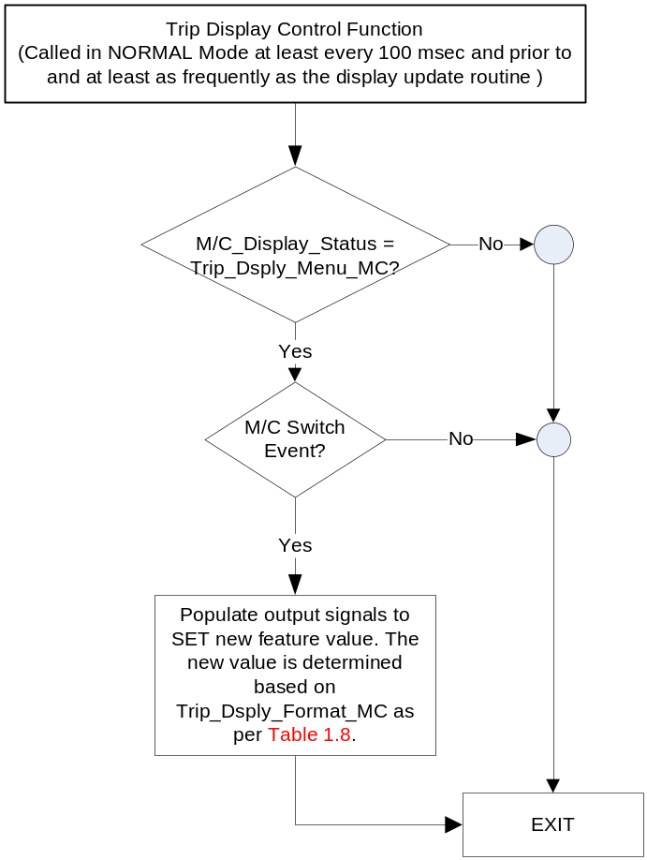

NOTE: 1.) In the Trip Display Control Function Flowchart, the definition of "M/C Switch Event" is defined in Message Center Switch - 5 Button XXX Interface STSS, where XXX is either CAN or H/W as is appropriate.
2.) This menu is not present in the S-HMI Simplified Menu. The Simplified Menu has only one display type.

Figure 1.7 Routine Flowchart – RESET due to LifeCycMde
(There are similar Routines in FE and DTE STSSs. They can be combined into one routine. If they are not combined, you must use unique variables for LCMde_NN in each routine.)

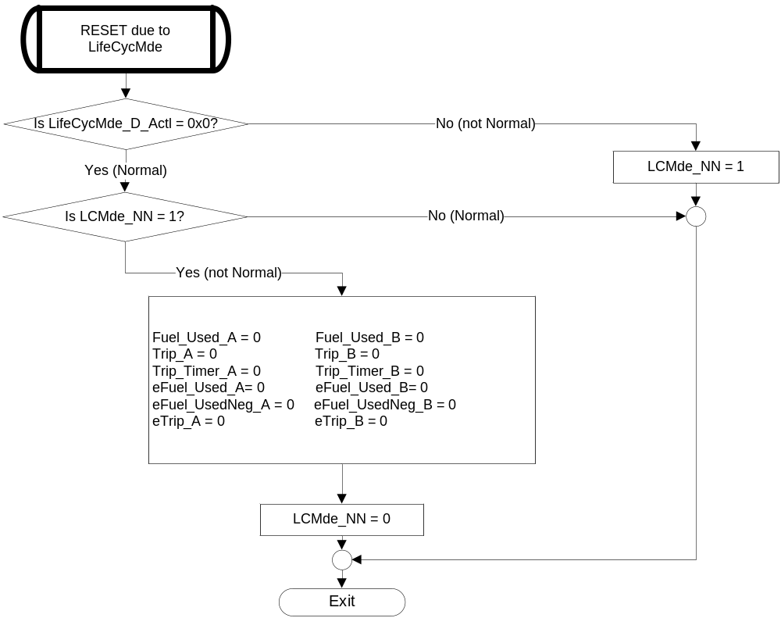

Operation Description (supports algorithm flowchart /state diagram)

- OK_Switch_Press_Event is TRUE when:
  - the “OK_Reset_Switch_Press_Event” that is indicated as per the switch interface for the Message Center is TRUE.
- OK_Switch_Press_Event is FALSE for all other conditions and after being “consumed”.
- OK_Switch_Release_Event is TRUE when:
  - the “OK_Switch_Release_Event” that is indicated as per the switch interface for the Message Center is TRUE.
- OK_Switch_Release_Event is FALSE for all other conditions and after being “consumed”.
- OK_Switch_Hold_Timer is active (greater than 0.0 seconds) and increases to indicate the time since the last OK_Switch_Press_Event was set to TRUE and before the last OK_Switch_Release_Event was set to TRUE.
- OK_Switch_Hold_Timer is set to 0.0 when an OK_Switch_Release_Event is set to TRUE.
- The displays for Trip distance traveled, fuel used and time will roll over individually when it reaches its maximum display value. An example would be a Trip display value of 9999.9 rolls over to 0.0 while the other trip variables continue to increase.
- The following TripStats Displays are only Graphic Representations. See Ford Studio released Drawing for exact graphics. Also, only the simple Trip Stats Display is shown. There is a counterpart for each of these that depict the same state in the “4 variable” display.

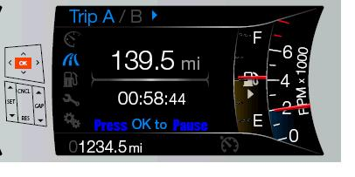
  - TripStats_Display_0 when Trip_X_Status_MC = 0

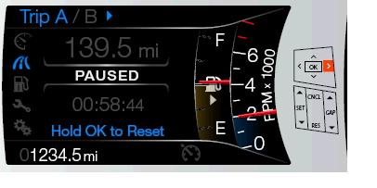
  - TripStats_Display_1 when Trip_X_Status_MC = 1

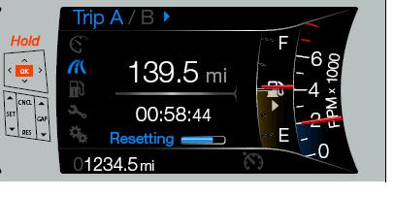
  - TripStats_Display_2 when Trip_X_Status_MC = 2

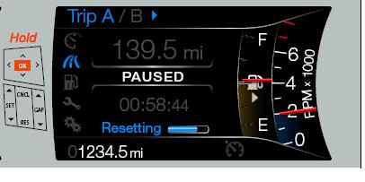
  - TripStats_Display_3 when Trip_X_Status_MC = 3

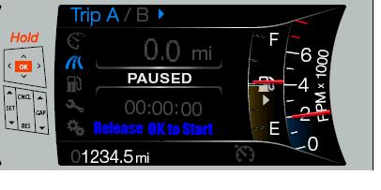
  - TripStats_Display_4 when Trip_X_Status_MC = 4

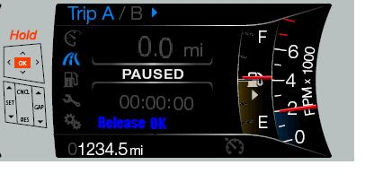
  - TripStats_Display_5 when Trip_X_Status_MC = 5

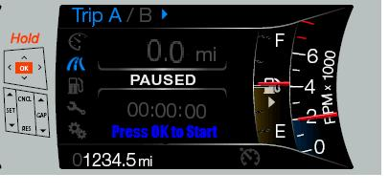
  - TripStats_Display_6 when Trip_X_Status_MC = 6

- The text below the Trip Stats values shall be as follows:
o State Text
o ========= =========
o State 0 Hold OK To Reset
o State 1 Hold OK To Reset
o State 2 Resetting
o State 2 -> 0 Reset Cancelled (displayed for ~2 seconds)
o State 2 -> 4 Reset Complete (displayed for ~2 seconds)
o State 4 Release OK to Start (displayed after in State 4 for 2 seconds)
o State 3 Resetting
o State 3 -> 1 Reset Cancelled (displayed for 2 seconds)
o State 3 -> 5 Reset Compete (displayed for 2 seconds)
o State 5 Release OK (displayed after in State 5 for 2 seconds)
o State 6 Press OK to Start

- The use of 32 Bit Interger variables allows for the following:

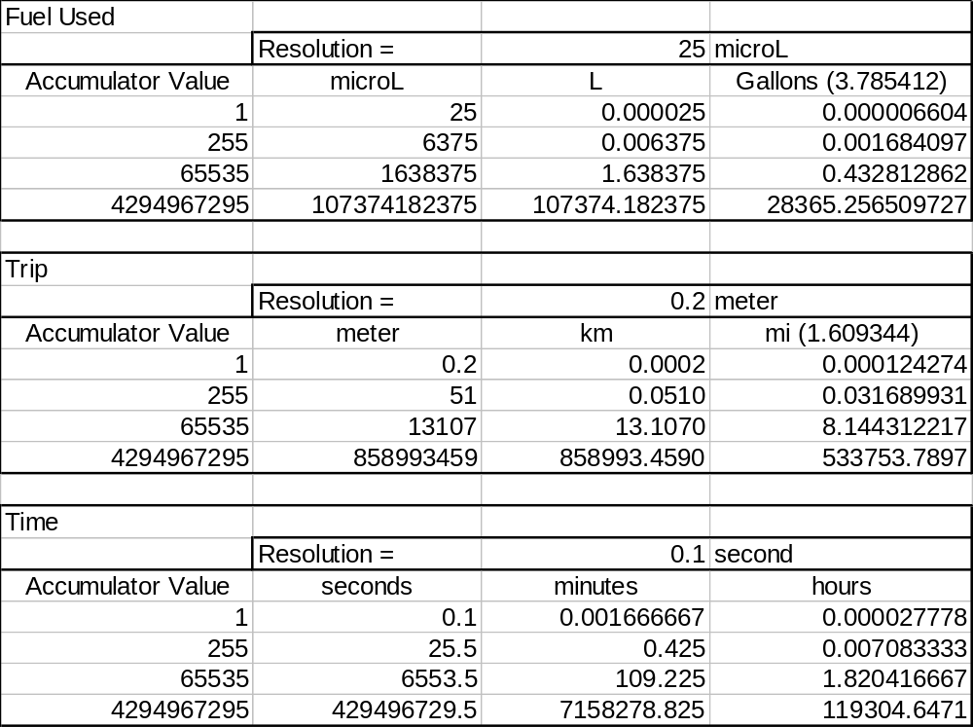

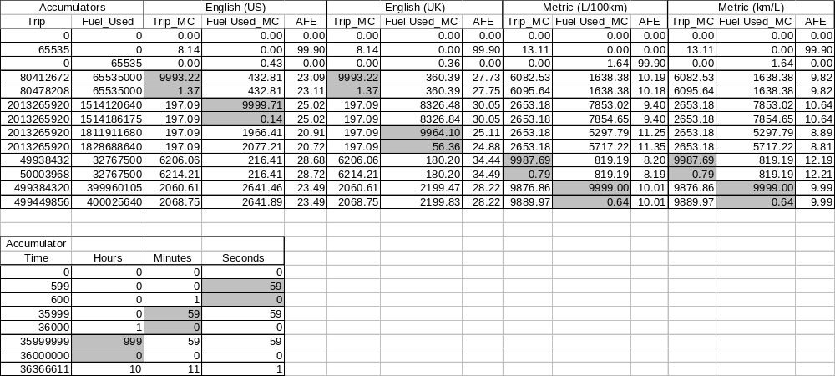

- The customer will have the ability to change the AFE display format between Gasoline Engine Only Average Fuel Economy (AFE) and Equivalent Average Fuel Economy (eAFE). The method for this is specified in the Fuel Economy STSS. This document specifies the value to be displayed for both AFE and eAFE. The eAFE values are initialized so that it will not impact the AFE calculation if there is no EV mode.
- The customer will have the ability to change between the Standard and Enhanced Trip Stat Display when the Instrument Cluster Message Center is enabled (Operational Mode is Normal)

- HMI Display based upon Trip_Dsply_Format_MC
Trip_Dsply_Format_MC | Display Menu | 5-Button Switch Selection Event | Trip_Dsply_Format_MC
0x0 | 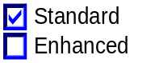 | Up/Down + OK (Select Enhanced) | 0x1
0x1 | 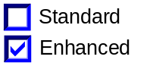 | Up/Down + OK (Select Standard) | 0x0

Function Safety Classification (EMC)

Class B

Memory Storage

Parameter Name | Description | Value at Battery connect | Value at  Module Wake-up
OdoCount | CAN signal used to transmit distance traveled to the cluster | 0 | 0
FuelFlw_Vl_Dsply | CAN signal used to transmit fuel used to the cluster | 0 | 0
ElFuelFlw_Vl_Dsply | CAN signal used to transmit equivalent fuel used in EV Auto Deplete and EV Now modes to the cluster | 0 | Do Not Init
EngActv_B_Dsply | CAN signal used to transmit state of gasoline engine to the cluster | 0 | Do Not Init
LifeCycMde_D_Actl | CAN input signal used to provide information about which Carmode the vehicle is in i.e. Normal, factory etc. | 0x0 | 0x0
Trip _A | Internal variable stored in battery backed memory and used to track distance traveled during the execution of the Trip Stats A algorithm. 32 Bit Integer variable with each count equal to 0.2 meter. | Use Stored Value | Use Stored Value
Trip _A_EE | Internal variable stored in EEPROM (NVM) and used to track distance traveled during the execution of the Trip Stats A algorithm. 32 Bit Integer variable with each count equal to 0.2 meter. Initial value programmed is 0. | If (Trip _A_EE > Odometer) Then Odometer Else Trip_A_EE | Trip _A_EE
Trip_A_MC | Output variable stored in battery backed memory and used by Message Center for Trip A Distance in units of current M/C display setting. Range from 0.0 to 9999.9. | 0 | Do Not Init
eTrip_A | Internal variable stored in battery backed memory and used to track EV distance traveled during the execution of the Trip Stats A algorithm. 32 Bit Integer variable with each count equal to 0.2 meter. | Use Stored Value | Use Stored Value
eTrip_A_EE | Internal variable stored in EEPROM (NVM) and used to track EV distance traveled during the execution of the Trip Stats A algorithm. 32 Bit Integer variable with each count equal to 0.2 meter. Initial value programmed is 0. | If (eTrip _A_EE > Odometer) Then Odometer Else eTrip_A_EE | eTrip _A_EE
eTrip_A_MC | Output variable stored in battery backed memory and used by Message Center for Trip A EV Distance in units of current M/C display setting. Range from 0 to 9999. | 0 | Do Not Init
Trip _B | Internal variable stored in battery backed memory and used to track distance traveled during the execution of the Trip Stats B algorithm. 32 Bit Integer variable with each count equal to 0.2 meter. | Use Stored Value | Use Stored Value
Trip _B_EE | Internal variable stored in EEPROM (NVM) and used to track distance traveled during the execution of the Trip Stats B algorithm. 32 Bit Integer variable with each count equal to 0.2 meter. Initial value programmed is 0. | If (Trip _B_EE > Odometer) Then Odometer Else Trip_B_EE | Trip _B_EE
Trip_B_MC | Output variable stored in battery backed memory and used by Message Center for Trip B Distance in units of current M/C display setting. Range from 0.0 to 9999.9. | 0 | Do Not Init
eTrip_B | Internal variable stored in battery backed memory and used to track EV distance traveled during the execution of the Trip Stats B algorithm. 32 Bit Integer variable with each count equal to 0.2 meter. | Use Stored Value | Use Stored Value
eTrip_B_EE | Internal variable stored in EEPROM (NVM) and used to track EV distance traveled during the execution of the Trip Stats B algorithm. 32 Bit Integer variable with each count equal to 0.2 meter. Initial value programmed is 0. | If (eTrip _B_EE > Odometer) Then Odometer Else eTrip_B_EE | eTrip _B_EE
eTrip_B_MC | Output variable stored in battery backed memory and used by Message Center for Trip B EV Distance in units of current M/C display setting. Range from 0 to 9999. | 0 | Do Not Init
Fuel_Used_A | Internal variable stored in battery backed memory and used to track fuel used during the execution of the Trip Stats A algorithm. 32 Bit Integer variable with each count equal to 25 microL. | Fuel_Used_A_EE | Fuel_Used_A_EE
Fuel_Used _A_EE | Internal variable stored in EEPROM (NVM) and used to track fuel used during the execution of the Trip Stats A algorithm. 32 Bit Integer variable with each count equal to 25 microL. Initial value programmed is 0. | Use Stored Value | Use Stored Value
Fuel_Used _A_MC | Output variable stored in battery backed memory and used by Message Center for Trip A Fuel Used in units of current M/C display setting. Range from 0.0 to 9999.99. | 0 | Do Not Init
eFuel_Used_A | Internal variable stored in battery backed memory and used to track equivalent fuel used during the execution of the Trip Stats A algorithm. 32 Bit Integer variable with each count equal to 25 microL. | eFuel_Used_A_EE | eFuel_Used_A_EE
eFuel_Used _A_EE | Internal variable stored in EEPROM (NVM) and used to track equivalent fuel used during the execution of the Trip Stats A algorithm. 32 Bit Integer variable with each count equal to 25 microL. Initial value programmed is 0. | Use Stored Value | Use Stored Value
eFuel_UsedNeg_A | Internal variable stored in battery backed memory and used to track equivalent fuel usedNeg (regened) during the execution of the Trip Stats A algorithm. 32 Bit Integer variable with each count equal to 25 microL. | eFuel_UsedNeg_A_EE | eFuel_UsedNeg_A_EE
eFuel_UsedNeg _A_EE | Internal variable stored in EEPROM (NVM) and used to track equivalent fuel usedNeg (regened) during the execution of the Trip Stats A algorithm. 32 Bit Integer variable with each count equal to 25 microL. Initial value programmed is 0. | Use Stored Value | Use Stored Value
Fuel_Used_B | Internal variable stored in battery backed memory and used to track fuel used during the execution of the Trip Stats B algorithm. 32 Bit Integer variable with each count equal to 25 microL. | Fuel_Used_B_EE | Fuel_Used_B_EE
Fuel_Used _B_EE | Internal variable stored in EEPROM (NVM) and used to track fuel used during the execution of the Trip Stats B algorithm. 32 Bit Integer variable with each count equal to 25 microL. Initial value programmed is 0. | Use Stored Value | Use Stored Value
eFuel_UsedNeg_B | Internal variable stored in battery backed memory and used to track equivalent fuel usedNeg (regened) during the execution of the Trip Stats B algorithm. 32 Bit Integer variable with each count equal to 25 microL. | eFuel_UsedNeg_B_EE | eFuel_UsedNeg_B_EE
eFuel_UsedNeg _B_EE | Internal variable stored in EEPROM (NVM) and used to track equivalent fuel usedNeg (regened) during the execution of the Trip Stats B algorithm. 32 Bit Integer variable with each count equal to 25 microL. Initial value programmed is 0. | Use Stored Value | Use Stored Value
Fuel_Used _B_MC | Output variable stored in battery backed memory and used by Message Center for Trip B Fuel Used in units of current M/C display setting. Range from 0.0 to 9999.99. | 0 | Do Not Init
eFuel_Used_B | Internal variable stored in battery backed memory and used to track equivalent fuel used during the execution of the Trip Stats B algorithm. 32 Bit Integer variable with each count equal to 25 microL. | eFuel_Used_B_EE | eFuel_Used_B_EE
eFuel_Used _B_EE | Internal variable stored in EEPROM (NVM) and used to track equivalent fuel used during the execution of the Trip Stats B algorithm. 32 Bit Integer variable with each count equal to 25 microL. Initial value programmed is 0. | Use Stored Value | Use Stored Value
Trip_Timer_A | Internal variable stored in battery backed memory and used to track elapsed time during the execution of the Trip Stats A algorithm. 32 Bit Integer variable with each count equal to 0.1 second. | Trip_Timer_A_EE | Trip_Timer_A_EE
Trip_Timer_A_EE | Internal variable stored in EEPROM (NVM) and used to track elapsed time during the execution of the Trip Stats A algorithm. 32 Bit Integer variable with each count equal to 0.1 second. Initial value programmed is 0. | Use Stored Value | Use Stored Value
Trip_Hours_A_MC | Output integer variable stored in battery backed memory and used by Message Center for Trip A Timer in units of hours. Range from 0 to 999. | 0 | Do Not Init
Trip_Minutes_A_MC | Output integer variable stored in battery backed memory and used by Message Center for Trip A Timer in units of minutes. Range from 0 to 59. | 0 | Do Not Init
Trip_Seconds_A_MC | Output integer variable stored in battery backed memory and used by Message Center for Trip A Timer in units of seconds. Range from 0 to 59. | 0 | Do Not Init
Trip_Timer_B | Internal variable stored in battery backed memory and used to track elapsed time during the execution of the Trip Stats B algorithm. 32 Bit Integer variable with each count equal to 0.1 second. | Trip_Timer_B_EE | Trip_Timer_B_EE
Trip_Timer_B_EE | Internal variable stored in EEPROM (NVM) and used to track elapsed time during the execution of the Trip Stats B algorithm. 32 Bit Integer variable with each count equal to 0.1 second. Initial value programmed is 0. | Use Stored Value | Use Stored Value
Trip_Hours_B_MC | Output integer variable stored in battery backed memory and used by Message Center for Trip B Timer in units of hours. Range from 0 to 999. | 0 | Do Not Init
Trip_Minutes_B_MC | Output integer variable stored in battery backed memory and used by Message Center for Trip B Timer in units of minutes. Range from 0 to 59. | 0 | Do Not Init
Trip_Seconds_B_MC | Output integer variable stored in battery backed memory and used by Message Center for Trip B Timer in units of seconds. Range from 0 to 59. | 0 | Do Not Init
Trip_AFE_A_MC | Output variable stored in battery backed memory and used by Message Center for Trip A Average Fuel Economy in units of current M/C display setting. Range from 0.0 to 999.9. | 0 | Do Not Init
Trip_AFE_B_MC | Output variable stored in battery backed memory and used by Message Center for Trip B Average Fuel Economy in units of current M/C display setting. Range from 0.0 to 999.9. | 0 | Do Not Init
Trip_eAFE_A_MC | Output variable stored in battery backed memory and used by Message Center for Trip A equivalent Average Fuel Economy in units of current M/C display setting. Range from 0.0 to 999.9. | 0 | Do Not Init
Trip_eAFE_B_MC | Output variable stored in battery backed memory and used by Message Center for Trip B equivalent Average Fuel Economy in units of current M/C display setting. Range from 0.0 to 999.9. | 0 | Do Not Init
kWh_A_MC | Output variable stored in battery backed memory and used by Message Center for Trip A electrical power used in units of kiloWatthours. Range from 0.0 to 999.9 | 0 | Do Not Init
kWh_B_MC | Output variable stored in battery backed memory and used by Message Center for Trip B electrical power used in units of kiloWatthours. Range from 0.0 to 999.9 | 0 | Do Not Init
Trip_A_Status_MC | Output variable stored in battery backed memory and used as a state indication for Trip A Status : | Trip_A_Status_EE | Trip_A_  Status_EE
  Status | Accumulate | OK Held (.5-2 s) | OK Held (>2 s) | OK  Released after Reset
  0 | Yes | No | No | Don’t Care
  1 | No | No | No | No
  2 | Yes | Yes | No | NA
  3 | No | Yes | No | NA
  4 | No | No | Yes | NA
  5 | No | No | Yes | NA
  6 | No | No | No | Yes
Trip_A_Status_EE | Internal variable stored in EEPROM (NVM) and used as a state indication for Trip A Status:  Initial value programmed is 0. | Use Stored Value | Use Stored Value
  Status | Accumulate | OK Held (.5-2 s) | OK Held (>2 s) | OK  Released after Reset
  0 | Yes | No | No | Don’t Care
  1 | No | No | No | No
  2 | Yes | Yes | No | NA
  3 | No | Yes | No | NA
  4 | No | No | Yes | NA
  5 | No | No | Yes | NA
  6 | No | No | No | Yes
Trip_B_Status_MC | Output variable stored in battery backed memory and used as a state indication for Trip B Status: | Trip_B_Status_EE | Trip_B_  Status_EE
  Status | Accumulate | OK Held (.5-2 s) | OK Held (>2 s) | OK  Released after Reset
  0 | Yes | No | No | Don’t Care
  1 | No | No | No | No
  2 | Yes | Yes | No | NA
  3 | No | Yes | No | NA
  4 | No | No | Yes | NA
  5 | No | No | Yes | NA
  6 | No | No | No | Yes
Trip_B_Status_EE | Internal variable stored in EEPROM (NVM) and used as a state indication for Trip B Status:  Initial value programmed is 0. | Use Stored Value | Use Stored Value
  Status | Accumulate | OK Held (.5-2 s) | OK Held (>2 s) | OK  Released after Reset
  0 | Yes | No | No | Don’t Care
  1 | No | No | No | No
  2 | Yes | Yes | No | NA
  3 | No | Yes | No | NA
  4 | No | No | Yes | NA
  5 | No | No | Yes | NA
  6 | No | No | No | Yes
Trip_Error_Flag_MC | Output variable stored in battery backed memory and used as a state indication for error Trip calculation:  0 = No Error (Valid)  1 = Error | 0 | 0
LCMde_NN | Internal Flag in battery-backed RAM for previous LifeCycMde_D_Actl where 0 is = “Normal” mode and 1 is = “not Normal” mode | 0 | Do Not Init
Previous_FF | Last previously received FuelFlw_Vl_Dsply value | 0 then Init to first received FuelFlw_Vl_Dsply | Init to first received FuelFlw_Vl_Dsply
Previous_ElFF | Last previously received ElFuelFlw_Vl_Dsply value | 0 then Init to first received ElFuelFlw_Vl_Dsply | Init to first received ElFuelFlw_Vl_Dsply
Previous_FF_FOH | Last previously received FuelFlw_Vl_ActlFoh value or EconometerFFH value (if C1MCA architecture vehicle) | 0 then Init to first received FuelFlw_VI_ActlFoh | Do Not Init
Previous_ODO | Last previously received OdoCount value | 0 then Init to first received OdoCount | Init to first received OdoCount
OdoCount_Delta_A | Change in travel from previous processed value | 0 | 0
ElOdoCount_Delta_A | Change in Eltravel from previous processed value | 0 | 0
Fuel_Flow_Delta_A | Change in fuel used from previous processed value | 0 | 0
ElFuel_Flow_Delta_A | Positive Change in Elfuel used from previous processed value | 0 | 0
ElFuel_Flow_DeltaNeg_A | Negative Change in Elfuel used from previous processed value | 0 | 0
OdoCount_Delta_B | Change in travel from previous processed value | 0 | 0
ElOdoCount_Delta_B | Change in Eltravel from previous processed value | 0 | 0
Fuel_Flow_Delta_B | Change in fuel used from previous processed value | 0 | 0
ElFuel_Flow_Delta_B | Positive Change in Elfuel used from previous processed value | 0 | 0
ElFuel_Flow_DeltaNeg_B | Negative Change in Elfuel used from previous processed value | 0 | 0
OK_Switch_Press_Event | Event that is indicated as per the switch interface for the Message Center | See Message Center Switch STSS | See Message Center Switch STSS
OK_Switch_Release_Event | Event that is indicated as per the switch interface for the Message Center | See Message Center Switch STSS | See Message Center Switch STSS
OK_Switch_Hold_Timer | The timer that has elapsed since an OK_Switch_Press_Event and before an OK_Switch_Release_Event, which stops and sets the value to 0. | See Message Center Switch STSS | See Message Center Switch STSS
Display_Units_MC | Input to this routine that controls display indicating units to the driver (i.e. when English: miles, mpg; when Metric: km, L/100 km, km/L). Parameter is to be stored in Battery Backed RAM. | Used Stored Value (See Display Unit Selection Control Function STSS) | Do Not Init
M/C_Display_Status | Input to this routine that is a State Indicator to identify which text is currently being displayed on Message Center display. | As per Menu Structure Section (STSS) | As per Menu Structure Section (STSS)
Trip_Dsply_Format_MC | Output used to control the Trip Stat Display and the Settings Display Menu. States are 0x0 (Standard) and 0x1 (Enhanced). Parameter is to be stored in Battery Backed RAM. | 0x0 | Do Not Init
Operational_Mode | Input to this routine that is a 4 State indicator for cluster operational mode | As per Operational Modes and Voltage Range Strategies Section (STSS) | As per Operational Modes and Voltage Range Strategies Section (STSS)
PT_Hyb_Cfg | EOL configures cluster for the type of Powertrain in the vehicle. This NVM parameter shall be set equal to 0x0 for Non-Hybrid 0x1 for Bev, 0x2 for FHEV and 0x3 for PHEV.  Default to be 0x0 from Cluster plant if cluster program includes Non-Hybrid, | Use Stored Value | Use Stored Value
Trip_Stats_Pause_Cfg | Internal variable stored in EEPROM (NVM) configures cluster to display allow pause of Trip Stats. This NVM parameter shall be set equal (0x0) for Disabled, and (0x1) for Enabled. | Use Stored Value | Use Stored Value
AFE_Reset_Cfg | EOL configures cluster for the type of filter to be used in the AFE display. This NVM parameter shall be set equal to (0x1) for Ford Global FE Display Strategy using “- -” and RAFE. However, RAFE will not be used since the weight values are not reset. (0x0 should not be used). | Use Stored Value | Use Stored Value
Trip_AFE_A_Reset_Filter_Timer | Timer used to show dashes after an AFE Reset of Trip A. Timer expires after 20s. | Not Active | Not Active
Trip_AFE_B_Reset_Filter_Timer | Timer used to show dashes after an AFE Reset of Trip B. Timer expires after 20s. | Not Active | Not Active
EngAout_N_Actl (CAN) | Engine RPM used after AFE Reset to determine if engine is running | 0 (0x0) | 0 (0x0)
AFE_Bias_Factor | This is an ETM adjustable bias factor with a range of values from 800 to 1200 (resolution 1). Default value is 1000, which corresponds to zero bias. (i.e. the customer is shown the internal calculation). Parameter is stored in EEPROM. | Use Stored Value | Use Stored Value
FuelFlw_Vl_ActlFoh (CAN) | CAN signal from FOH used to transmit fuel used to the cluster. The FOH only sets this value to 0 when the PCM/ECM loses KAM. | 0 until first received signal value | Do Not Init
EconometerFFH (CAN) | C1MCA signal for C34x PHEV/FHEV only. CAN signal from fuel fired heater (FFH, also called fuel operated heater or FOH) used to transmit fuel used to the cluster. The FFH only sets this value to 0 when the PCM/ECM loses KAM. | 0 until first received signal value | Do Not Init
Odometer | Total accumulated vehicle distance traveled that is displayed. Storage: EEPROM. Resolution and range set by supplier to match requirements in this SPSS. | Use Stored Value | Use Stored Value

Prove Out
No

Reconfigurable Telltale
No

Message Center Msg
Refer to Ford Studio Drawing

Error Handling

Missing Message Strategy

The signals will be declared missing as per the Diagnostics Section of this SPSS.

If any of the input signals are determined to be MISSING, this function shall follow the flowchart, and all displayed Fuel Economies shall be dashes. (Exception: Note that missing signal FuelFlw_Vl_ActlFoh or EconometerFFH does not cause display to show dashes).
This function shall indicate as per its state matrix within 100mS of receiving a valid message.

Invalid Data Strategy

When OdoCount is Invalid (0xFF) for greater than 5 seconds, the cluster shall log DTC C40100 and all displayed Fuel Economies shall be dashes. When OdoCount is Invalid (0xFF) for less than 5 seconds, this function shall follow the flowchart. This function shall indicate as per its state matrix within 100mS of receiving valid OdoCount data.

Diagnostics

Self Test
None

Engineering Test Mode

Reference section “Dealer / Engineering Test Mode (ETM)”.
For AFE_Bias_Factor requirements, reference this section in Fuel Economy STSS.

Part II Performance

Supported Diagnostic Trouble Codes (DTCs)
DTC | Description | When Logged
C10000 | Lost Communication With ECM/PCM "A" | OdoCount signal or FuelFlw_VI_Dsply signals missing for at least 5 consecutive seconds.
C40168 | Invalid Data Received From ECM/PCM | OdoCount signal is Invalid for at least 5 consecutive seconds

DID DEXX
Bits | State: Description | "0" | "1" | Default | Comments/  Information
1 | Fuel Operated Heater (FOH) | Disabled | Enabled | Disabled | See Fuel Operated Heater Control Function for definition
2 | PT Hybrid |  |  | 0x0 | Default from cluster plant to be 0x0 if cluster can be used on a Non-Hybrid.
 | 0x0 = Non-Hybrid
 | 0x1 = BEV
 | 0x2 = FHEV
 | 0x3 = PHEV
1 | Trip Stats Pause | Disabled | Enabled | Disabled | Controls the availability of the pause in Trip Stats
1 | AFE Reset | No Filter | Filter using  “- -“ and RAFE | 0x1 Filter | 0x1 globally.  Note: 0x0 is legacy NA strategy. Current direction is to not carry this forward.

Reference Specification

IS-0247 RUNNING AVERAGE FUEL ECONOMY [RAFE] DEFAULT (MSGCENTR)
IS-0300 ACCURACY (CLOCKS)
IS-0303 ELAPSED TIME PERFORMANCE (CLOCKS)
IS-0307 ACCURACY - TRIP DISTANCE (SPEEDOM)
IS-0344 GENERAL REQUIREMENTS (MSGCENTR)
IS-0348 ACCURACY - FUEL USED (MSGCENTR)
IS-0358 ACCURACY – AVERAGE FUEL ECONOMY (MSGCENTR)
IS-0360 IGNITION ON TIME (CLOCKS)
IS-0379 NORTH AMERICAN WARNINGS AND INDICATORS STRATEGY

Revision History

SPSS Module Revision History

Revision Level | Name | Change Description | Date
1.0 | SWatkins  via TCwik | Initial Release (started from AFE with Nav STSS Ver 3.0) | 5/22/2008
2.0 | SWatkins  via TCwik | - Section 1.3.5.1 - Figure 1.2 Changed “0,2 or 4?” to “0 or 2?” in four Decision Diamonds  - Section 1.3.5.1 - Figure 1.3 Changed “0,2 or 4?” to “0 or 2?” in first Decision Diamond,  - Section 1.3.5.1 - Figure 1.3 Part A changed “OK_Switch_Hold_Timer >=0.5?” to “OK_Switch_Hold_Timer >=0.25?” in two places  - Section 1.3.5.1 - Figure 1.3 Part B changed “Trip_AFE_A” to “Trip_AFE_A_MC” 6 places, “Trip_AFE_B” to “Trip_AFE_B_MC” 6 places  - Section 1.3.5.2 Changed “double precision” to “32 Bit Integer”  - Section 1.3.5.4 Changed “Double Precision” to “32 Bit” 12 places and changed the Accumulate entry for State 4 to “No” for Trip_A_Status_MC, Trip_A_Status_EE, Trip_B_Status_MC and Trip_B_Status_EE | 3/10/2009
2.1 | SWatkins  via TCwik | - Section 1.3.5.1 - Figure 1.3 Changed “0, 2 or 4?” to “0 or 2?” in first Decision Diamond after Identifier A (page 6) | 3/13/2009
2.2 | SWatkins  via TCwik | - Section 1.3.5.1 - Figure 1.3 for Trip A changed “OK_Switch_Hold_Timer >=0.5?” to “OK_Switch_Hold_Timer >=0.25?” in two places | 7/15/2009
2.3 | SWatkins  via TCwik | - Section 1.3.3.2.2 – Changed “gray” to “omitted" in 4 places  - Section 1.3.5.1 - Figure 1.3 for Trip A changed “Trip_Status_A = 0 or 2?” to “Trip_A_Status_MC = 0 or 2?” and for Trip B changed  “Trip_Status_B = 0 or 2?” to “Trip_B_Status_MC = 0 or 2?” | 7/21/2009
2.4 | SWatkins  via TCwik | - Section 1.3.3.2.2 – Changed Fuel Used to XXXZ.ZZ from XXXZ.Z  - Section 1.3.5.4 – Changed Description for Fuel_Used _A_MC and Fuel_Used _B_MC to have a maximum Range value of 9999.99 from 9999.9. | 5/13/2010
3.0 | SWatkins | Issues with “odometer creep” on key cycles have been appearing on different programs. The root cause is that some PCM’s will set OdoCount to 0 on wakeup, but not send 0 upon transition to Run/Start. Also, some PCM’s will just hold last value across key cycle. To become robust to all these variations, we are switching the cluster logic to just use the first value received after a key cycle as your reference (instead of assuming 0).  It was also discovered that some cluster suppliers do not have FNOS configured to signal when a new message is received for periodic messages. Thus, a less desirable implementation is also described.  Instead of acting upon the receipt of the Engine_Data_7 message, they poll the value of OdoCount 10ms after key in RUN, regardless of whether a new message has been received.  Note that with the less desirable implementation, that it is possible to get the odometer to creep if conditions are correct. However, it would only occur with the first quick key cycle.  The same issue exists with fuel flow (FuelFlw_Vl_Dsply)  Specifics:  - Section 1.2.2 – Re-wrote bullet points. (strikethrough text replaced with 3 bullets below).  - At every transition to RUN/START OdoCount Signal value is reset to zero.  - At every transition to RUN/START, the expected value of OdoCount is reset to the value in the first received CAN OdoCount signal.  - For clusters that do not have FNOS configured to generate an event when a periodic message is received, the following (less desirable) alternate implementation of the above requirement is allowed:  - At every transition to RUN/START, the expected value of OdoCount is reset to the value in the CAN Rx buffer.  - Section 1.2.2 – Re-wrote bullet points. (strikethrough text replaced with 3 bullets below).  - At every transition to RUN/START FuelFlw_Vl_Dsply signal value is reset to zero.  - At every transition to RUN/START, the expected value of FuelFlw_Vl_Dsply is reset to the value in the first received CAN FuelFlw_Vl_Dsply signal.  - For clusters that do not have FNOS configured to generate an event when a periodic message is received, the following (less desirable) alternate implementation of the above requirement is allowed:  - At every transition to RUN/START, the expected value of FuelFlw_Vl_Dsply is reset to the value in the CAN Rx buffer. | 7/16/2010
4.0 | SWatkins | Major Update to bring in global requirements for CGEA 1.3.  Brought in updates to match updates performed on Fuel Economy (AFE, AFE Histogram, IFE, LT, DC, MyKey) - CGEA1.3_v5.0.doc STSS.  - Section 1.1 – Updated description to mention FOH.  - Section 1.2.1 – Updated Figure 1.1 to add FOH_Cfg, AFE_Bias_Factor, FuelFlw_VI_ActlFoh, RAFE, and EngAout_N_Actl.  - Section 1.2.2 - Added Table 1.2 and Table 1.3 for FuelFlw_VI_ActlFoh and EngAout_N_Actl.  - Section 1.3.3.2 – Added note that Fuel used should have 2 decimal places  - Section 1.3.5.1 – Re-wrote Figure 1.2 CAN Routine. First change was to get rid of right hand side flows that calculated fuel used when OdoCount is missing. That is not necessary. Then, added logic to handle Fuel Operated Heater fuel consumed.  - Figure 1.3 (first page) – Modified “Yes” path of decision diamond for “Is Trip_Error_Flag_MC = 0x1?” to exit down right side. Also added an action under Trip_A_Status = 4 to Start the Trip_AFE_A_Reset_Filter_Timer.  - Figure 1.3 (second page) – Modified “Yes” path of decision diamond for “Is Trip_Error_Flag_MC = 0x1?” to exit down right side. Also added an action under Trip_B_Status = 4 to Start the Trip_AFE_B_Reset_Filter_Timer.  - Figure 1.3 (third page) – added subroutine calls to Trip_AFE_Display_Filter_A and Trip_AFE_Display_Filter_B.  - Added new Figure 1.4 - Trip_AFE_Display_Filter.  - Section 1.3.5.4 – Added new parameters at bottom of table.  - Section 1.4 – Re-wrote to match CGEA 1.3 format  - Section 1.5.3 – Added Fuel Operated Heater config to DID DE00. | 12/8/2010
4.1 | TCwik1 | 1 - Figure 1.3 (first page) – Added actions under Trip_A_Status = 4 to set Weight_AFE_A = 0% and Weight_RAFE_A = 100%  Added actions under Trip_A_Status = 5 to  Start the Trip_AFE_A_Reset_Filter_Timer and to set Weight_AFE_A = 0% and Weight_RAFE_A = 100%  2 - Figure 1.3 (second page) Added actions under Trip_B_Status = 4 to set Weight_AFE_B = 0% and Weight_RAFE_B = 100%  Added actions under Trip_B_Status = 5 to  Start the Trip_AFE_B_Reset_Filter_Timer and to set Weight_AFE_B = 0% and Weight_RAFE_B = 100%  3 - Figure 1.4 – Added Decision Diamonds “Is Trip_X_Status_MC = 4 or %?” and “Is Weight_RAFE_X < 0.033%?” and its associated Action Box. | 8/23/2011
5.0 | TCwik1 | This change adds eTrip and eAFE for PHEV.  - Section 1.1 – Added text concerning eTrip and eAFE and its sub-functions  - Section 1.2.1 –  - Added PT_Hyb_Cfg, ElFuelFlw_Vl_Dsply. eTrip_A_MC, eTrip_B_MC, Trip_eAFE_A_MC, Trip_eAFE_B_MC, kWh_A_MC, kWh_B_MC, EngActv_B_Dsply and Trip_Dsply_Format_MC to Figure 1.1  - Changed Display_Units to Display_Units_MC in figure 1.1  - Deleted AFE_Metric_Display_Type_Cfg and Gallon_Display_Type_Cfg from Figure 1.1  (Continued on Next Page) | 10/26/2011
5.0  (continued) | TCwik1 | This change adds eTrip and eAFE for PHEV.  - Section 1.2.2 –  - Changed Display_Units to Display_Units_MC  - Added “and Previous_FF” to first tic point after Table 1.0  - Added Table 1.1 and tic points, renumbered all following Tables  - Added “and Previous_ODO” to second tic point after Table 1.2  - Added “and Previous_FF_FOH” to first tic point after Table 1.3  - Added Table 1.6  - Section 1.2.3 – Added eTrip_A_MC, eTrip_B_MC, Trip_eAFE_A_MC, Trip_eAFE_B_MC, kWh_A_MC, kWh_B_MC and Trip_Dsply_Format_MC  - Section 1.3.3.2 – Updated entire section with new graphics and text.  - Section 1.3.3.2.2 –  - Updated AFE to XXZ.Z  - Added eAFE and kWh Used  - Section 1.3.5.1 –  - Updated Figure 1.2 –  - Added Decision Diamond about PT_Hyb_Cfg  - Added Decision Diamond about EngActv_B_Dsply and the following Action Box about ElOdoCount_Delta_  - Added Decision Diamond and Action Boxes about ElFuelFlw  - Added Previous_ElFF action to Action Box that updates previous values.  - Updated Figure 1.3 (Start) –  - Added Decision Diamonds about eFuel_Used_A, eFuel_UsedNeg_A and eTrip_A  - Added “eFuel_Used_A = 0”, “eFuel_UsedNeg_A” and “eTrip_A = 0” to 3 Action Boxes  - Added eFuel_Used_A, eFuel_UsedNeg_A and eTrip_A equations to Action Box  - Added ElFuel_Flow_Delta_A = 0,ElFuel_Flow_DeltaNeg_A= 0 and ElOdoCount_A = 0 to Action Box  - Updated Figure 1.3 (A) –  - Added Decision Diamonds about eFuel_Used_B, eFuel_UsedNeg_B and eTrip_B  - Added “eFuel_Used_B = 0”, “eFuel_UsedNeg_B = 0” and “eTrip_B = 0” to 3 Action Boxes  - Added eFuel_Used_B, eFuel_UsedNeg_B and eTrip_B equations to Action Box  - Added ElFuel_Flow_Delta_B = 0, ElFuel_Flow_DeltaNeg_B=0 and ElOdoCount_B = 0 to Action Box  - Updated Figure 1.3 (B) –  - Divided flowchart into two flowcharts (B & C) and updated most of the flow, Action Boxes and Decision Diamonds  - Updated Figure 1.4 –  - Added input Variable Y to subroutine in Starting Point and in two Action Boxes  - Updated Figure 1.5 –  - Added eTrip_A_EE, eTrip_B_EE, eFuel_Used_A_EE, eFuel_Used_B_EE, eFuel_UsedNeg_A_EE and eFuel_UsedNeg_B_EE to Action Box  - Added Figure 1.6  - Section 1.3.5.2 –  - Added a tic point (The text below the Trip Stats …)  - Added a tic point about AFE Display (The customer will have …)  - Added a tic point about Trip Display (The customer will have …) and Table 1.7  (Continued on Next Page) | 10/26/2011
5.0  (continued) | TCwik1 | This change adds eTrip and eAFE for PHEV.  - Section 1.3.5.4 –  - Added ElFuelFlw_Vl_Dsply. EngActv_B_Dsply, eTrip_A, eTrip_A_EE, eTrip_A_MC, eTrip_B, eTrip_B_EE, eTrip_B_MC, eFuel_Used_A, eFuel_Used_A_EE eFuel_UsedNeg_A, eFuel_UsedNeg_A_EE, eFuel_Used_B eFuel_Used_B_EE, eFuel_UsedNeg_B, eFuel_UsedNeg_B_EE, Trip_eAFE_A_MC, Trip_eAFE_B_MC, kWh_A_MC, kWh_B_MC, Previous_ElFF, Previous_FF_FOH, ElFuel_Flow_Delta_A, ElFuel_Flow_DeltaNeg_A, ElFuel_Flow_Delta_B, ElFuel_Flow_DeltaNeg_B. ElOdoCount_Delta_A, ElOdoCount_Delta_B, Trip_Dsply_Format_MC, PT_Hyb_Cfg, FOH_Cfg  - Deleted AFE_Metric_Display_Type_Cfg and Gallon_Display_Type_Cfg  - Updated Trip_AFE_A_MC and Trip_AFE_B_MC to 999.9  - Changed Display_Units to Display_Units_MC  - Section 1.5.3 – Deleted Gallon Display Type and AFE Metric Display Type from DE00 Table  - Added PT Hybrid  To reduce variations of STSS, have introduced C1MCA architecture signals. These are only used for C34x PHEV/FHEV program at this time. Since these signals are non-global, these additions will eventually be removed from this STSS. These changes are shown in bright green in the STSS.  - Section 1.2.1, Figure 1.1 – Added signal EconometerFFH to Context Diagram.  - Section 1.2.2 – Added Table 1.4 for EconometerFFH  - Section 1.3.5.1.– Added new Figure 1.2a which uses EconometerFFH signal.  - Section 1.3.5.4 – Added new signal EconometerFFH and updated description of Previous_FF_FOH. | 10/26/2011
6.0 | T. Cwik | This change is to correct some logic errors in the algorithm on the implementation for the CGEA 1.3/CM1CA when the Fuel Operated Heater is present.  Section 1.3.5.1 –  - Figure 1.2 and 1.2a – Removed Decision Diamond in each (“FOH_Cfg=0x1?”) in order to count fuel used by non-park FOH.  - Figure 1.2a – Added a “*80” to the increased fuel used amount due to the EconometerFFH value in the Action Box for the Fuel_Flow_Delta_A and Fuel_Flow_Delta_B equations.  - Figure 1.3 – Changed Decision Diamond to include a subtraction of 65536 for Fuel_Used_A  - Figure 1.3 (Section A) – Changed Decision Diamond to include a subtraction of 65536 for Fuel_Used_B  Section 1.4.1 – Added EconometerFFH to note about exception. | 3/10/2012
6.1 | T. Cwik | On PHEV vehicles, the kWh formula had an error. This change only affects PHEV.  This is to correct the equation for kWh to use Mod instead of Max and “-“ instead of “+”.  Section 1.3.5.1 – Changed the equation for kWh_A_MC in Figure 1.3 Part “B” Flowchart and kWh_B_MC in Figure 1.3 Part “C” Flowchart.  Corrected the following typo.  Section 1.3.5.1 – Figure 1.3 – Changed eFuel_Used_ANeg to eFuel_UsedNeg_A | 5/23/2012
6.2 | T. Cwik | Correction for AFE display filtering on PHEV where RAFE does not change due to EV Mode being active. Per Q&A #1366 and #1367.  Section 1.3.5.1 – Figure 1.4 – Added Decision Diamond (PT_Hyb_Cfg = 0?) and its associated “No” path.  Correction in the equation for kWh to indicate 0 for negative values.  Section 1.3.5.1 – Changed the equation for kWh_A_MC in Figure 1.3 Part “B” Flowchart and kWh_B_MC in Figure 1.3 Part “C” Flowchart. | 6/12/2012
6.3 | T.Cwik | Updated to make the Pause Feature DID DE0X controllable.  Section 1.2.1 – Figure 1.1 – Added Trip Stats Pause and Trip_Stats_Pause_Cfg  Section 1.3.5.1 – Figure 1.3 –  - Updated Action Boxes to Trip_A_Status_MC = Trip_Stats_Pause_Cfg and Trip_B_Status_MC = Trip_Stats_Pause_Cfg  - Removed the notes above these two Action Boxes  - Changed “1,3,4 & 6” to “1,3,5 & 6” in the two HMI Program Direction Notes  Section 1.3.5.4 – Added Trip_Stats_Pause_Cfg  Section 1.5.3 – Added Trip Stats Pause to DID DE0X | 9/14/2012
7.0 | T. Cwik | Update to correct minor errors from previous updates.  Section 1.2.1 – Figure 1.1 Trip Stats Function Context Diagram  – Removed input signal Veh_V_ActlEng as it was not used.  – Added EngAout_N_Actl as input signal.  Section 1.3.5.1 –  – Figure 1.2 and 1.2a – Added note “When EngActive_B_Dsply…”  – Figure 1.4 –  – Note added (Note: A similar AFE Routine…)  – Changed the path from “Displayed … (dashes)” Action Box to Exit  – Changed the equation for Displayed Trip_Y_X_MC in Action Box  Section 1.3.5.4 – Removed Row containing Veh_V_ActlEng  As directed by outcomes of recent meetings on AFE Display, AFE displays will have an option to display two ways after an AFE Reset. One will be with “—“ and RAFE and the other will be with cleared AFE. The one to use will depend upon the value of AFE_Reset_Cfg.  The changes for this are the following.  - Section 1.2.1 – Figure 1.1 – Added AFE Reset and AFE_Reset_Cfg  - Section 1.3.5.1 – Figure 1.4 – Added Decision Diamond for “AFE_Reset_Cfg”. Deleted Decision Diamond for “Trip_X__Status_MC= 4 or 5”, so that FE will be 0.0 MPG after a Reset until the Reset Button is Released.  - Section 1.3.5.4 – Added AFE_Reset_Cfg  - Section 1.5.3 – Added AFE Reset to DEXX Table | 6/27/2013
7.1 | T. Cwik | Update to correct minor error from previous update.  Section 1.3.5.1 – Figure 1.4 – Changed the “No” path from “Is EngAoutN_Actl >= 400 PRM?” Decision Diamond to go to Exit. | 8/2/2013
7.2 | SWatkins | A system issue was discovered with FOH module regarding CAN signal FuelFlw_Vl_ActlFoh. When transitioning to RUN, this signal will unexpectedly send “0” for a short time, then send the correct value. The agreed upon implementation is for the cluster to not accumulate and ignore the 0 value.  - Section 1.2.2 – Modified 2nd bullet point under Table 1.3, also added 3rd bullet point  - Section 1.3.5.1, Figure 1.2 – Added new decision diamond near bottom of page to check for FuelFlw_Vl_ActlFoh = 0. | 4/11/2014
7.3 | T. Cwik | This change removes the changes done in Revision 17.1 because the FOH module is being updated so that it only sends out valid data and uses the 0 value at battery connect and as a rolling count value. | 5/6/2014
8.0 | T.Cwik | As per the Vehicle Engineer Fuel Economy Global DNA direction, this update:  1.) corrects an error in the use of the AFE_Bias_Factor,  2.) adds a reset AFE after leaving plant Mode,  3.) corrects minor errors.  - Section 1.2.1 – Figure 1.1 – Added LifeCycMde_D_Actl  - Section 1.2.2 –  – Updated note below Table 1.3 and Table 1.4  – Added Table 1.7, which caused a renumbering of all subsequent tables.  - Section 1.3.5.1 –  – Figure 1.2 – Added Notes.  – Figure 1.2a – Added Notes.  – Figure 1.3 – Added Routine Call (RESET due to LifeCycMde)  – Figure 1.3 Part B – Changed the equations for Fuel_Used_A_MC (3 places), Trip_AFE_A_MC (4 places), Trip_eAFE_A_MC (4 places) and “B” to “A” in two Subroutine Calls  – Figure 1.3 Part C – Changed the equations for Fuel_Used_B_MC (3 places), Trip_AFE_B_MC (4 places) and Trip_eAFE_B_MC (4 places)  – Figure 1.10 – Changed 2 Action Boxes equations for  Displayed Trip_Y_X_MC and added 3 Decision Diamonds (Display_Units_MC = 0xX?) and 4 associated Action Boxes  – Figure 1.6 – Added Note 2.  – Added Figure 1.7  - Section 1.3.5.4 –  – Changed the range of AFE_Bias_Factor, Battery Connect and Module Wake-up values for Previous_FF_FOH, FE_Previous_ODO, FE_Previous_FF and ElFE_Previous_FF  – Deleted FOH_Cfg  – Added LifeCycMde_D_Actl, LCMde_NN, RAFE_Dsply_TS  - Section 1.5.3 – DEXX Table – Updated comment for AFE Reset | 5/15/2014
8.1 | T. Cwik | Update to correct an error in the formula for Fuel Used. The error is only applicable when AFE_Bias_Factor is changed from default via ETM.  Section 1.3.5.1 –  – Figure 1.3 Section “B” – updated the formula for Fuel_Used_A_MC in three places  – Figure 1.3 Section “C” – updated the formula for Fuel_Used_B_MC in three places | 10/20/2014
9.0 | T. Cwik | Update to implement PRA #3449264 of trip odo being larger than odometer (items 1 thru 3) and to implement the latest Ford Global Strategy for displaying Fuel Economies as per the 3/10/2015 meeting (Jeff Holmes and Jon Chaprnka - display “- -“ for the first 20 seconds and 100m followed by an accurate AFE) (items 4 thru 6).  1.) Section 1.2.1 – Figure 1.1 – Added Odometer  2.) Section 1.2.2 – Added Odometer  3.) Section 1.3.5.4 – Added Odometer and changed the “Value at Battery connect” for Trip_A, eTrip_A, Trip_B and eTrip_B  4.) Section 1.3.5.1 – Figure 1.3 – Changed the values for the Weight_AFE_A, Weight_RAFE_A, Weight_AFE_B and Weight_RAFE_B in two places each.  5.) Section 1.3.5.4 –  – Changed the “Value at Battery connect” for Weight_AFE_A, Weight_AFE_B, Weight_RAFE_A and Weight_RAFE_B.  – Changed the description for AFE_Reset_Cfg  6.) Section 1.5.3 – Changed the columns associated with AFE Reset in the DID DExx table. | 3/20/2015
9.1 | R. Chalanti | Update to match this STSS with Trip Computer – Average Fuel Economies v 2.1, besides Denso query on CD4.1 for Q&A 179  correct minor error in Memory Storage. Ensures trip odo is never greater than Odometer  Correct L/100 km path to have max value of 99.9 L/100km, as 999.9 L/100km is 0.24 mpg  HMI Indicator section updated to match Fuel Economy v19.7 content | 9/21/2015
9.1 | R. Chalanti | Update to remove RAFE references in the STSS as it is no longer used | 4/12/2016

